Commits and Pushes

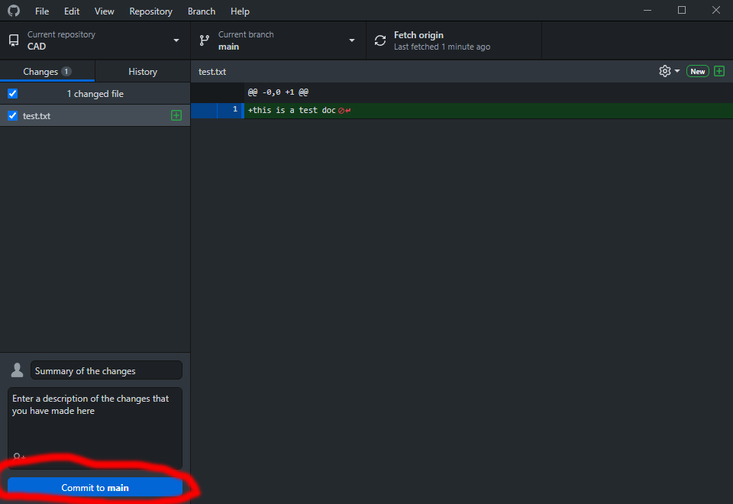

1. Fill out the lower left of the page with the info of the commit

-creates a commit, which is like a snapshot of your repository. These commits are snapshots of your entire repository at specific times.

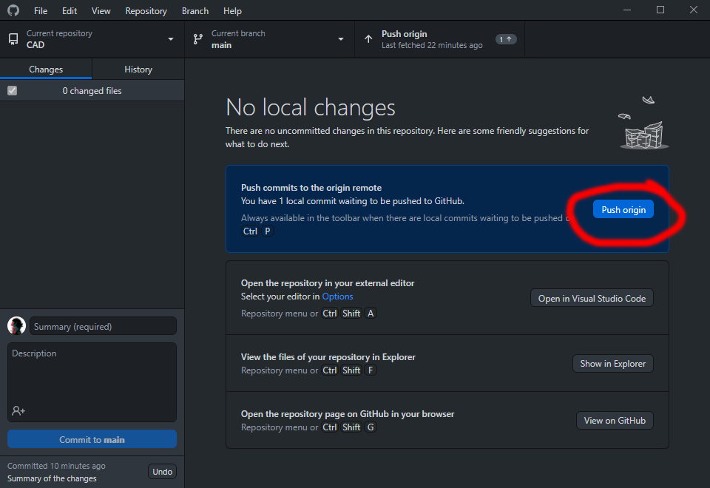

1. Hit push to push all of your local commits to a remote repository